Reading

https://classroommagazines.scholastic.com/support/learnathome/grades-3-5.html

https://www.getepic.com/

https://stories.audible.com/discovery

https://www.funbrain.com/books

https://www.storylineonline.net/library/

https://newsela.com/

Math

https://www.turtlediary.com/games/fifth-grade.html

http://www.sheppardsoftware.com/math.htm

https://gregtangmath.com/games

Science & Social Studies

https://www.brainpop.com/
Username: lenape09
Password: brainpop

https://kids.nationalgeographic.com/

https://explore.org/livecams/bald-eagles/decorah-eagles-north-nest
(EEGGCITING NEWS! Everyone congratulate 2 healthy Eaglets on Decorah North Cam !!!)

https://crafty.diply.com/121060/you-can-virtually-tour-a-whole-bunch-of-national-parks-from-your?utm_source=facebook&utm_medium=mnv2&utm_term=tst&utm_content=de002991

https://online.seterra.com/en/vgp/3003

https://www.turtlediary.com/games/fifth-grade/science.html

Breaks!
https://www.cosmickids.com/

https://family.gonoodle.com/

https://nationalzoo.si.edu/webcams

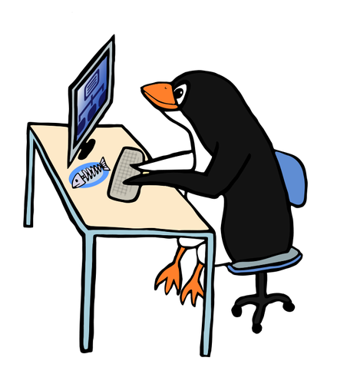

Typing Practice

https://www.typing.com/student/games

https://www.dancemattypingguide.com/

